*Florida International University*

*School of Computing and Information Sciences*

Software Engineering Focus

Feature Document

User Story ID #669

**Name:** Mario Fidalgo

**Team Member(s):** Kyle Ryan

**Project:** Mobile Judge 9.0

**Product Owner(s)**: Masoud Sadjadi

**Mentor(s)**: Masoud Sadjadi

**Instructor**: Masoud Sadjadi

**User Story Name: Add Filter Buttons to Grades**

**Description**

As an admin, I would like to be able to filter the students in the grade tab by the status of their grades (Accepted, Pending, Rejected).

**Acceptance Criteria**

* Buttons should filter the students by selected filter.
* The checkbox should select all or unselect all.
* The checkbox should display a third state when some of the filters are selected.

**Use Case**

* Name: Filter Grades
* Actor: Admin
* Preconditions: User must be logged in as an admin and in the grade view.
* Description <Flow of events>:

1. User clicks on a filter

2. System displays a view with only related data to the selected filter

**Use Case Diagram**

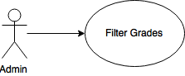

**Sequence Diagram**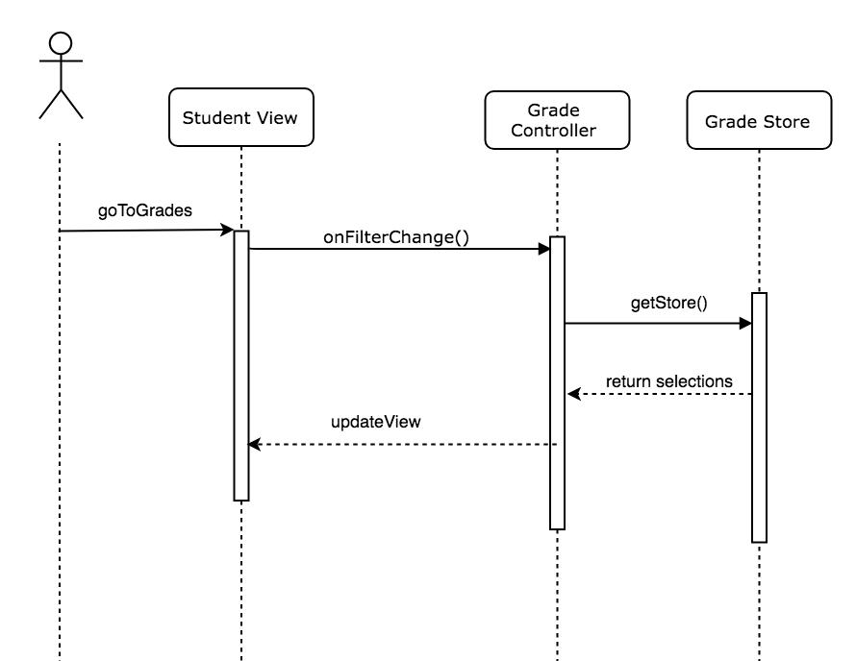

**Class Diagram**

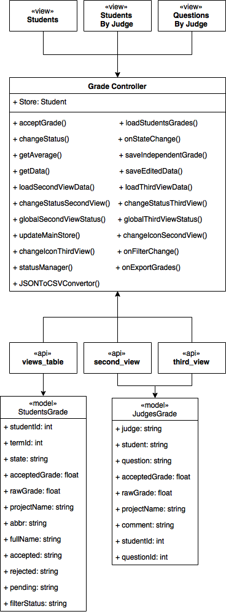

**Unit Test & Integration Test**

|  |
| --- |
| **Test case ID**: MJ-669-01  **Description/Summary of Test**: Filter all accepted grades  **Precondition**:   * Admin is currently logged into Mobile Judge account * Currently on the grade side tab * Viewing the student gridview * Selects accepted filter   **Expected Results:** Gridview updates and displays the appropriate records  **Actual Result:** Gridview updates and displays the appropriate records  **Status (Fail/Pass):** Pass |

|  |
| --- |
| **Test case ID**: MJ-669-02  **Description/Summary of Test**: Filter all pending grades  **Precondition**:   * Admin is currently logged into Mobile Judge account * Currently on the grade side tab * Viewing the student gridview * Selects pending filter   **Expected Results:** Gridview updates and displays the appropriate records  **Actual Result:** Gridview updates and displays the appropriate records  **Status (Fail/Pass):** Pass |

|  |
| --- |
| **Test case ID**: MJ-669-03  **Description/Summary of Test**: Filter all rejected grades  **Precondition**:   * Admin is currently logged into Mobile Judge account * Currently on the grade side tab * Viewing the student gridview * Selects rejected filter   **Expected Results:** Gridview updates and displays the appropriate records  **Actual Result:** Gridview updates and displays the appropriate records  **Status (Fail/Pass):** Pass |

|  |
| --- |
| **Test case ID**: MJ-669-04  **Description/Summary of Test**: Filter combinations of grade statuses  **Precondition**:   * Admin is currently logged into Mobile Judge account * Currently on the grade side tab * Viewing the student gridview * Selects any combination of filters   **Expected Results:** Gridview updates and displays the appropriate records  **Actual Result:** Gridview updates and displays the appropriate records  **Status (Fail/Pass):** Pass |

# 